Ideation Phase
Define the Problem Statements

Date | 16 June 2025
Team ID | LTVIP2025TMID58811
Project Name | Docspot
Maximum Marks | 2 Marks

Customer Problem Statement Template:
To define the core problems freelancers face while searching for jobs online, and use those insights to guide the development of Freelance Finder.
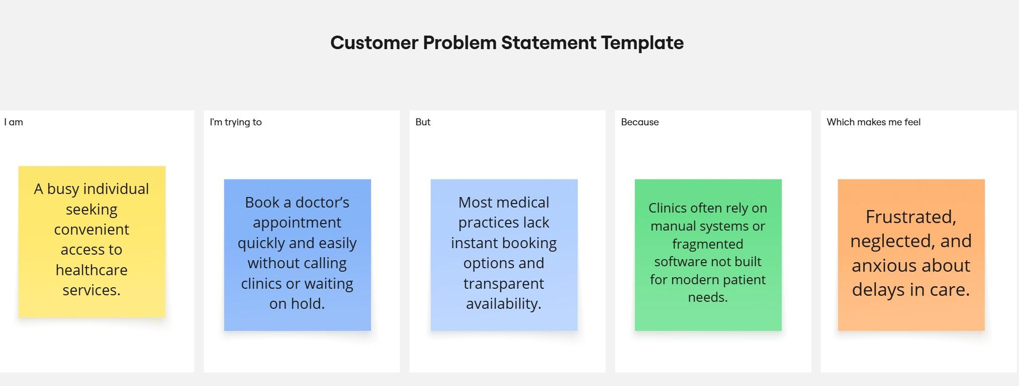
Reference: https://miro.com/templates/customer-problem-statement/

Problem Statement (PS) | I am (Customer) | I’m trying to | But | Because | Which makes me feel
PS-1 | a working professional with a tight schedule | book a doctor’s appointment quickly without phone calls or long wait times. | most clinics don’t have real-time booking systems or clear availability info | their systems are outdated or fragmented | frustrated and anxious about my health getting worse while waiting.
PS-2 | a general physician running a small clinic. | manage patient bookings efficiently and reduce no-shows. | my current tools are manual or not tailored to healthcare workflows. | I can’t afford or understand complex clinic management systems. | stressed and underpaid despite my busy schedule.
Project Team Members :

Sai Praneetha D
Sai varshitha S
Manogna D
Vedhanath Reddy M
Aveen Kumar S

